🧩 1. Modules in JavaScript (Node.js)

🔸 What is a Module?
A module is a separate file that contains reusable code (like a function, object, or variable).

🔸 Why use Modules?
- Reusability
- Better code organization
Term | Description
module.exports | Exports function/variable from a file
require() | Imports a module into another file
CommonJS | Module system used in Node.js
add.js | Custom module file

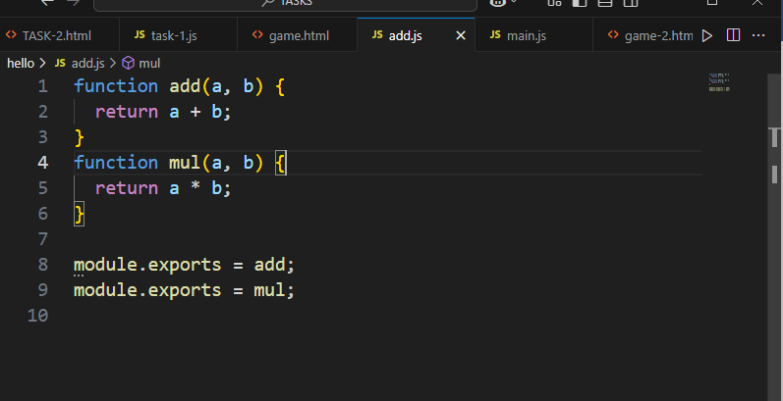

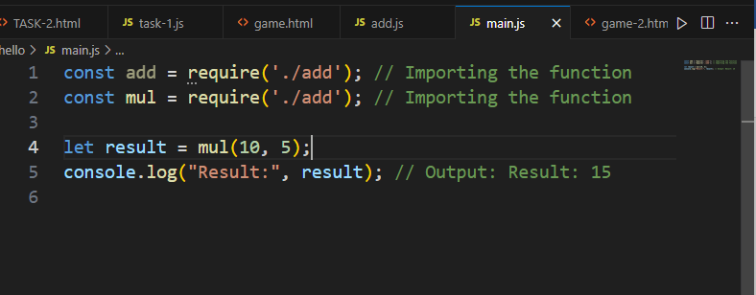

Second Code

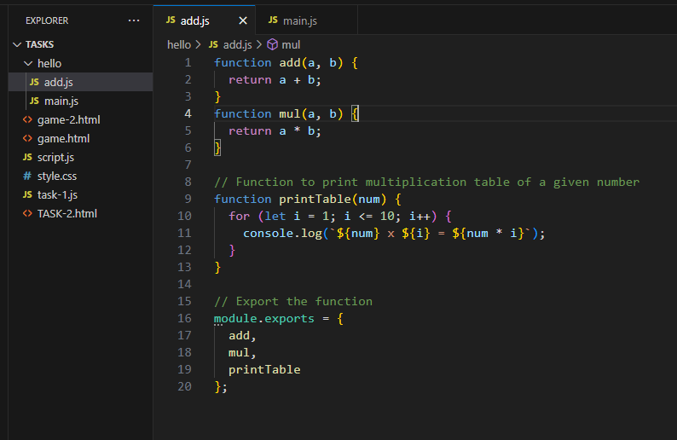

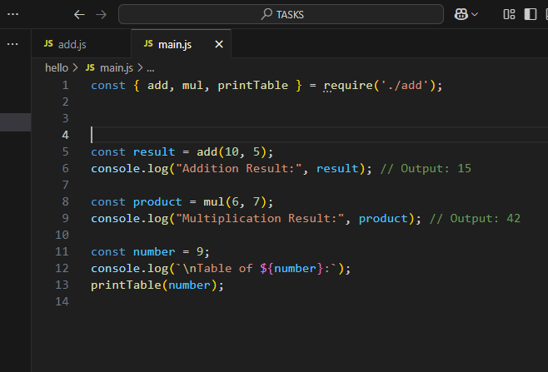

Execute Only Main.js File

Code

